Hi Andrew:

目前已將CPS_ETH IP固定下來，再調整ip後能夠使用putty登入 (password: root)，下方為相關MEMO資訊提供參考。

[1] Ethernet Static IP:

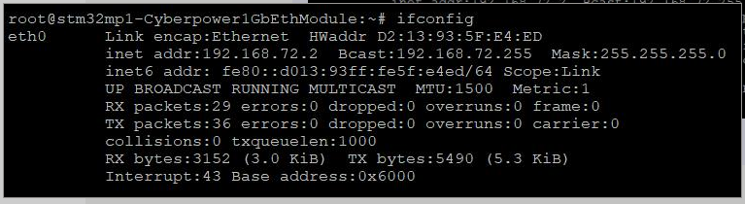

Reference:

<https://wiki.st.com/stm32mpu/wiki/How_to_configure_ethernet_interface#Using_systemd-networkd_service>

[2] How to disable Energy-Efficient Ethernet

$ ethtool –set-eee eth0 eee off

Reference:

<https://www.toradex.com/community/questions/14403/how-to-disable-energy-efficient-ethernet.html>

[3] Iperf3 On Windows

Iperf3 –s

Iperf3 –c <ip> -t

Reference:

<https://iperf.fr/iperf-download.php#windows>